OS LAB 08

Task
• Create a function message passing.
• This function will print any string with thread id.
• Create 4 independent threads for it.
• Pass thread id as an attribute to function message_passing.
• Finally join all these threads using pthread_join system call.

Code:

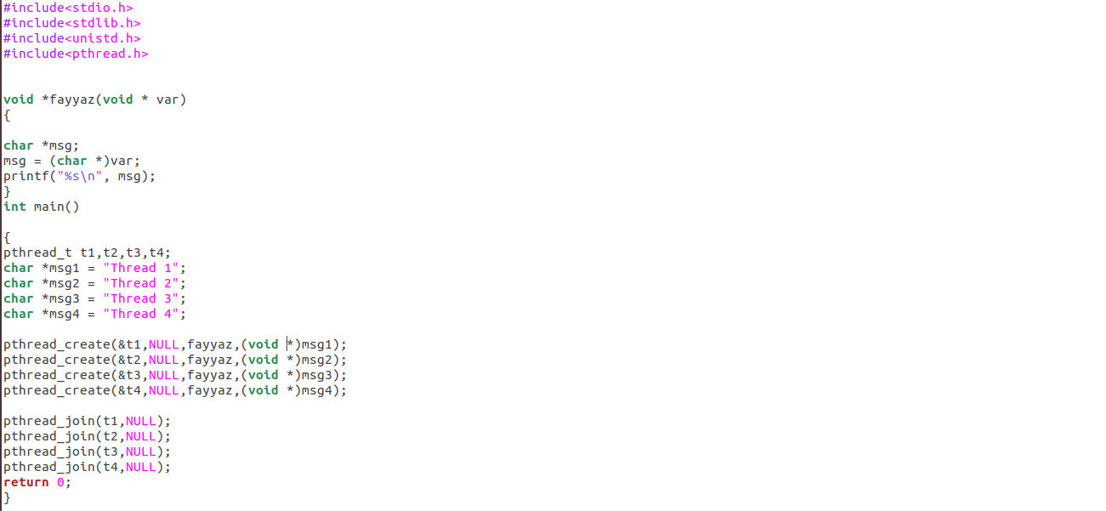

Output:

